COMMONWEALTH OF THE BAHAMAS
IN THE SUPREME COURT
CRIMINAL LAW DIVISION

2023/CRI/hcs/00017

IN THE MATTER OF A WAIT OF HABEAS CORPUS AD SYBJIENDUM
B E T W E E N
SADEKI GREG DAVY
Applicant
AND

THE ATTORNEY GENERAL OF THE BAHAMAS
1ST Respondent

AND

THE DIRECTOR OF IMMIGRATION
2ND Respondent

Before: THE HONOURABLE MR. JUSTICE GREGORY HILTON
Appearances Keith Seymour of the Applicant

Kirkland Mackey, Randolph Dames and
Monique Meronard for the Respondents

Hearing Dates: 19th December, 2023, 19th and 23rd January, 2024

DECISION

HILTON, J.

1. On 28th November, 2023 the Applicant applied ex parte for leave to issue a Writ of Habeas Corpus. The Court granted leave to the Applicant to file a Notice of Motion and set the 19th December, 2023 for an inter parte hearing.

2. The Applicant filed the Notice of Motion on 30th November, 2023 supported by Affidavit sworn by the Applicant and also filed on 30th November, 2023.

3. At the inter parte hearing on 19th December, 2023 the Court made an Order for the Applicant( a Jamaican National) not to be deported prior to a full hearing. The Court ordered the Writ of Habeas Corpus to be issued and the return to the Writ to be filed by the Respondent after eight (8) days and to be served on the Applicant. The Court set a hearing date for 19th January, 2024.

4. The Respondent filed a Return on 17th January, 2024 executed by the 2nd Respondent and also filed an Affidavit executed by Chedville Adams in support of the Return on behalf of the 1st and 2nd Respondents.

5. The Notice of Motion and Affidavit filed by the Applicant is set out below; and the Return to the Writ and Affidavit in support filed by the Respondents is also set out below.
”COMMONWEALTH OF THE BAHAMAS 2023
IN THE SUPREME COURT No.
PUBLIC CONSTITUTION (com law)

IN THE MATTER OF HABEAS CORPUS
BETWEEN
SADEKI GREG DAVY
Applicant
AND
THE ATTORNEY GENERAL OF THE BAHAMAS
First Respondent
AND
THE DIRECTOR OF IMMIGRATION
Second Respondent
NOTICE OF ORIGINAL MOTION

LET ALL PARTIES CONCERNED attend before a Judge of Supreme Court in Chambers, Bank Lane, Nassau, N.P., The Bahamas on Friday the 19th day of January A.D., 2024 at 10:00 in the am-noon on the hearing of an Application on behalf of the Applicant for an Order for the following reliefs, namely;

1. For leave to issue a Writ of Habeas Corpus directing the Director of Immigration to show cause why the Applicant should not be released immediately pending the outcome of his application for Asylum in the Bahamas; or in the alternative that he not be deported to Jamaica until a decision has been given on his application for asylum in the Bahamas;

2. A declaration that detention of the applicant pending his application for asylum contravened his right to liberty as enshrine in Article 19(1) and (3) of the Constitution of the Commonwealth of the Bahamas;

3. A declaration that the Applicant herein is a fit and proper candidate for Asylum and to deport him will surely cause his death and as such is a form of cruel and unusual treatment contrary to Article 17(1) of the Constitution of the Commonwealth of the Bahamas ;

4. Such further and other relief as the Honorable Supreme Court deems just; and

5. Cost.

Dated this 27th day of November, A.D., 2023

Filing Attorney: Keith A. Seymour
Firm: AKSUM LAW CHANBERS
Business Address: Aksum House
Okra Hill Road
Email: aksumlawchambers@yahoo.com
Telephone number: (242)3935984-5”

“COMMONWEALTH OF THE BAHAMAS
IN THE SUPREME COURT
PUBLIC CONSTITUTION (com law)

IN THE MATTER OF HABEAS CORPUS
BETWEEN
SADEKI GREG DAVY
Applicant
AND

THE ATTORNEY GENERAL OF THE BAHAMAS
First Respondent

AND

THE DIRECTOR OF IMMIGRATION
Second Respondent

NOTICE OF ORIGINATING MOTION

2023

No.

Filing Attorney: Keith A. Seymour
Firm: AKSUM LAW CHANBERS
Business Address: Aksum House
Okra Hill Road
Email: aksumlawchambers@yahoo.com
Telephone number: (242)3935984-5”

Attorney for the Applicant

“COMMONWEALTH OF THE BAHAMAS 2023
IN THE SUPREME COURT No.
PUBLIC CONSTITUTION (com law)

BETWEEN
SADEKI GREG DAVY
Applicant
AND
THE ATTORNEY GENERAL OF THE BAHAMAS
First Respondent
AND
THE DIRECTOR OF IMMIGRATION
Second Respondent
AFFIDAVIT
I SADEKI GREG DAVY, presently being held at The Detention Centre, Nassau Bahamas in the Southwest District of The Island of New Providence, one of the Island of The Commonwealth of the Bahamas do make oath and swear as follows:
1. That I am the Applicant herein.
2. That I am a citizen of Jamaica and that I was born on the 21st February 1988.
3. That I was arrested on the 24th of October A.D., 2023.
4. That I was taken before Magistrate Shaka Serville and was order to pay a fine. That the fine was paid on my behalf by Bahamian friends of my family.
5. That I have been detained at the Detention Centre since that date.
6. That I have made an application for Asylum herein the Bahamas because I am in great fear for my life I return to Jamaica.
7. That I came to the Bahamas due to an imminent threat to my life and the lives of my family and friends.
8. A ruthless and powerful criminal cartel has been targeting my family and myself for some time now.
9. We have been targeted and systematically eliminated through murder by this cartel because we refused to comply with their wishes.
10. After multiple members of my family have been murdered by this cartel for refusal to do their evil bidding, I had no choice but to flee the county and come here to the Bahamas.
11. It became evident that local authorities in Jamaica including but not limited to the Police and government officials are either complicit or under the influence of this criminal cartel as it became impossible for me to find protection or justice in my country.
12. Every attempt made by myself to relocate to other parts of the Jamaica resulted in attempts on my life even by officers of law enforcement and the cartel hench men who obviously gain information from persons working in these government institutions.

13. I have been living in constant apprehension for the past year as it has come to my knowledge that the reach of the cartel stretches far and wide and I do verily believe that the Bahamas is the only safe place for me right now because they are also very influential in America.
14. That several of my immediate family members have been murdered since this all begin, and I intend to produce their death certificates at hearing of my application.

SWORN TO BEFORE ME)
IN THE CITY OF NASSAU)
THIS 27TH DAY OF )
NOVEMBER A.D., 2023 )
BEFORE ME

NOTARY PUBLIC”

“COMMONWEALTH OF THE BAHAMAS
IN THE SUPREME COURT
2023

No.

PUBLIC CONSTITUTION (com law)
IN THE MATTER OF HABEAS CORPU

BETWEEN
SADEKI GREG DAVY
Applicant
AND
THE ATTORNEY GENERAL OF THE BAHAMAS
First Respondent
AND
THE DIRECTOR OF IMMIGRATION
Second Respondent

AFFIDAVIT

Filing Attorney: Keith A. Seymour
Firm: AKSUM LAW CHANBERS
Business Address: Aksum House
Okra Hill Road
Email: aksumlawchambers@yahoo.com
Telephone number: (242)3935984-5

ATTORNEY FOR THE APPLICANT”

“COMMONWEALTH OF THE BAHAMAS
IN THE SUPREME COURT
CRIMINAL LAW DIVISION
2023/CRI/hcs/00006

IN THE MATTER OF A WAIT OF HABEAS CORPUS AD SYBJIENDUM
B E T W E E N
SADEKI GREG DAVY
Applicant
AND

THE ATTORNEY GENERAL OF THE BAHAMAS
1ST Respondent

AND

THE DIRECTOR OF IMMIGRATION
2ND Respondent

RETURN
TO WRIT OF HABEAS CORPUS AD SUBJICIEDUM
(on behalf of the Respondent)

The return to this writ on behalf of the Respondents herein appears by Schedule annexed to the said writ as follows:
Schedule
I, William Pratt, Director of the Department of Immigration, declare that I am duly authorized to make this return on behalf of myself and the Respondents named in the writ to which this return is annexed.

I do hereby certify that on 24th October, 2023, the Applicant was in the area of Cow Pen Road and when he was questioned by Immigration and Police Officers. He was questioned and by the officers later information by them he was suspected of breaches and offences of the Immigration Act.

The Applicant was transported to the Carmichael Road Police Station and processed by police officers at the station. After processing, he was retrieved by Immigration Officers and transferred to the Carmichael Road Detention Centre. He was checked in the Immigration’s System which revealed he had no records of lawfully being in The Bahamas. No permit application was submitted on his behalf nor did he have any previous crossing in The Bahamas. The Applicant admitted to Immigration officers he entered into The Bahamas illegally and without his Jamaica passport. After the investigation he was informed and charged with the offence of illegal landing contrary to section 28(1) and (3) Immigration Act. The Applicant was processed, profiled and committed to the Carmichael Road Detention Centre.
On the 25th October, 2023, the Applicant was informed, explained and presented with a Detention and Deportation Order which he acknowledge and signed. He appeared before Magistrate Court #6 (Case no IMM/768/2023) where he was charged with Illegal Landing contrary to Section 19 (1) and punishable under section 19(2) Immigration Act.

He plead guilty was convicted and sentenced to a fine of $300.00. The Magistrate, by a Release Order (no 02672), released the Applicant in the custody of the Immigration Department and was transported to the Carmichael Road Detention Centre.

On 3rd November, 2023 the Minister responsible for Immigration signed the Deportation order and the Detention order designated by the Governor-General to signify the exercise of the powers conferred upon the Govern-General by section 41(4) of the Immigration Act.

On 24th November, 2023 travel arrangements were made for the Applicant to be deported to Jamaica on 29th November, 2023.

A request was sent to the Jamaica Consulate for an Emergency Travel Document but the Consulate replied in order to issue the same, confirmation must be made confirming the Applicant’s Jamaica nationality.

To date, the Immigration Department has not received proof of nationality or the Emergency Travel Document.

During this time awaiting deportation, the Applicant on 27th November, 2023, applied for asylum. He was interviewed by the Refugee Asylum Unit and during the interview the Applicant did not give sufficient information and evidence to establish a case for Asylum. On 1st December, 2023 it was determined he has not met the requirements of an asylum.

After being informed of his unsuccessful asylum application on 14th December, 2023, Counsel representing the Applicant informed and presented to the Immigration Department a writ of Habeas Corpus Application.

On 14th December, 2023, Jamaican Consulate was again allowed to speak freely with the Applicant.

On 19th December, 2023, Jamaican Consulate Doneth Cartwright, spoke with the Applicant and requested from the Immigration Department a passport photograph of the Applicant for Consulate’s profiling information.

The office of the Attorney General on 20th December, 2023, informed the Bahamas Immigration Department that the Applicant is not to be deported until/after the determination his habeas corpus application before Senior Justice Gregory Hilton.

Being equipped with Detention and Deportation Order, the only documents awaiting is relevant travel documentation and a final outcome of the habeas corpus application. So the Applicant can be deported.

I do hereby certify and return in obedience to the said writ the DADEKI GREY DAVY, the subject named therein, at the time of the application for the writ and the issuing of the said writ was detained at the Carmichael Road Detention Centre.

For the reason above, the Respondent prays that the writ herein be dismissed.

William Pratt
Director of the Bahamas Department of Immigration

Dated this 16th day of January, 2024

OFFICE OF THE ATTORNEY GENERAL
Paul L. Adderley Building
John F. Kennedy Drive
Nassau, The Bahamas”

Attorney for the Respondents

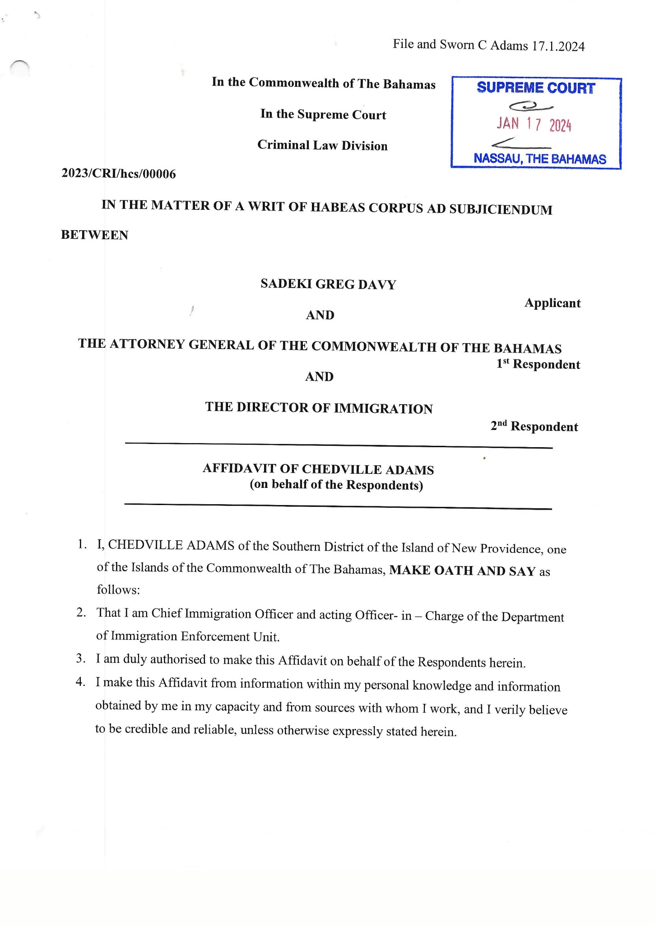
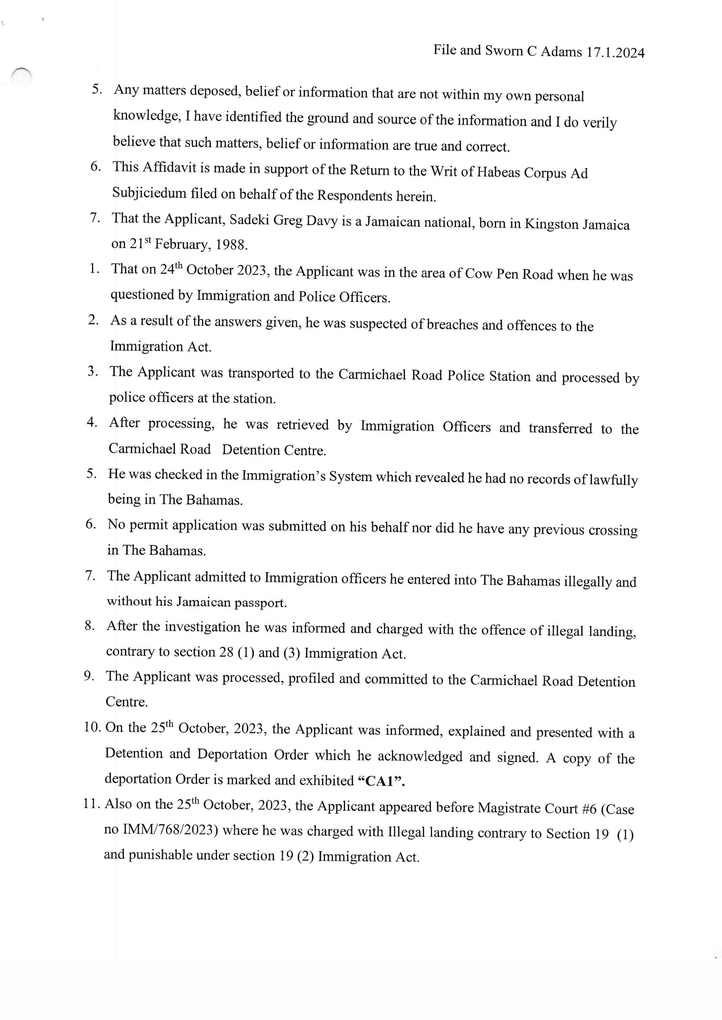
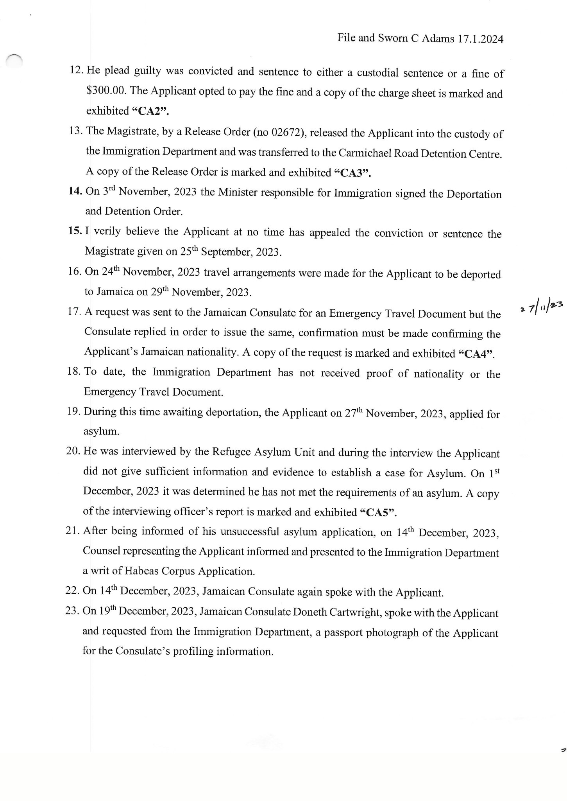
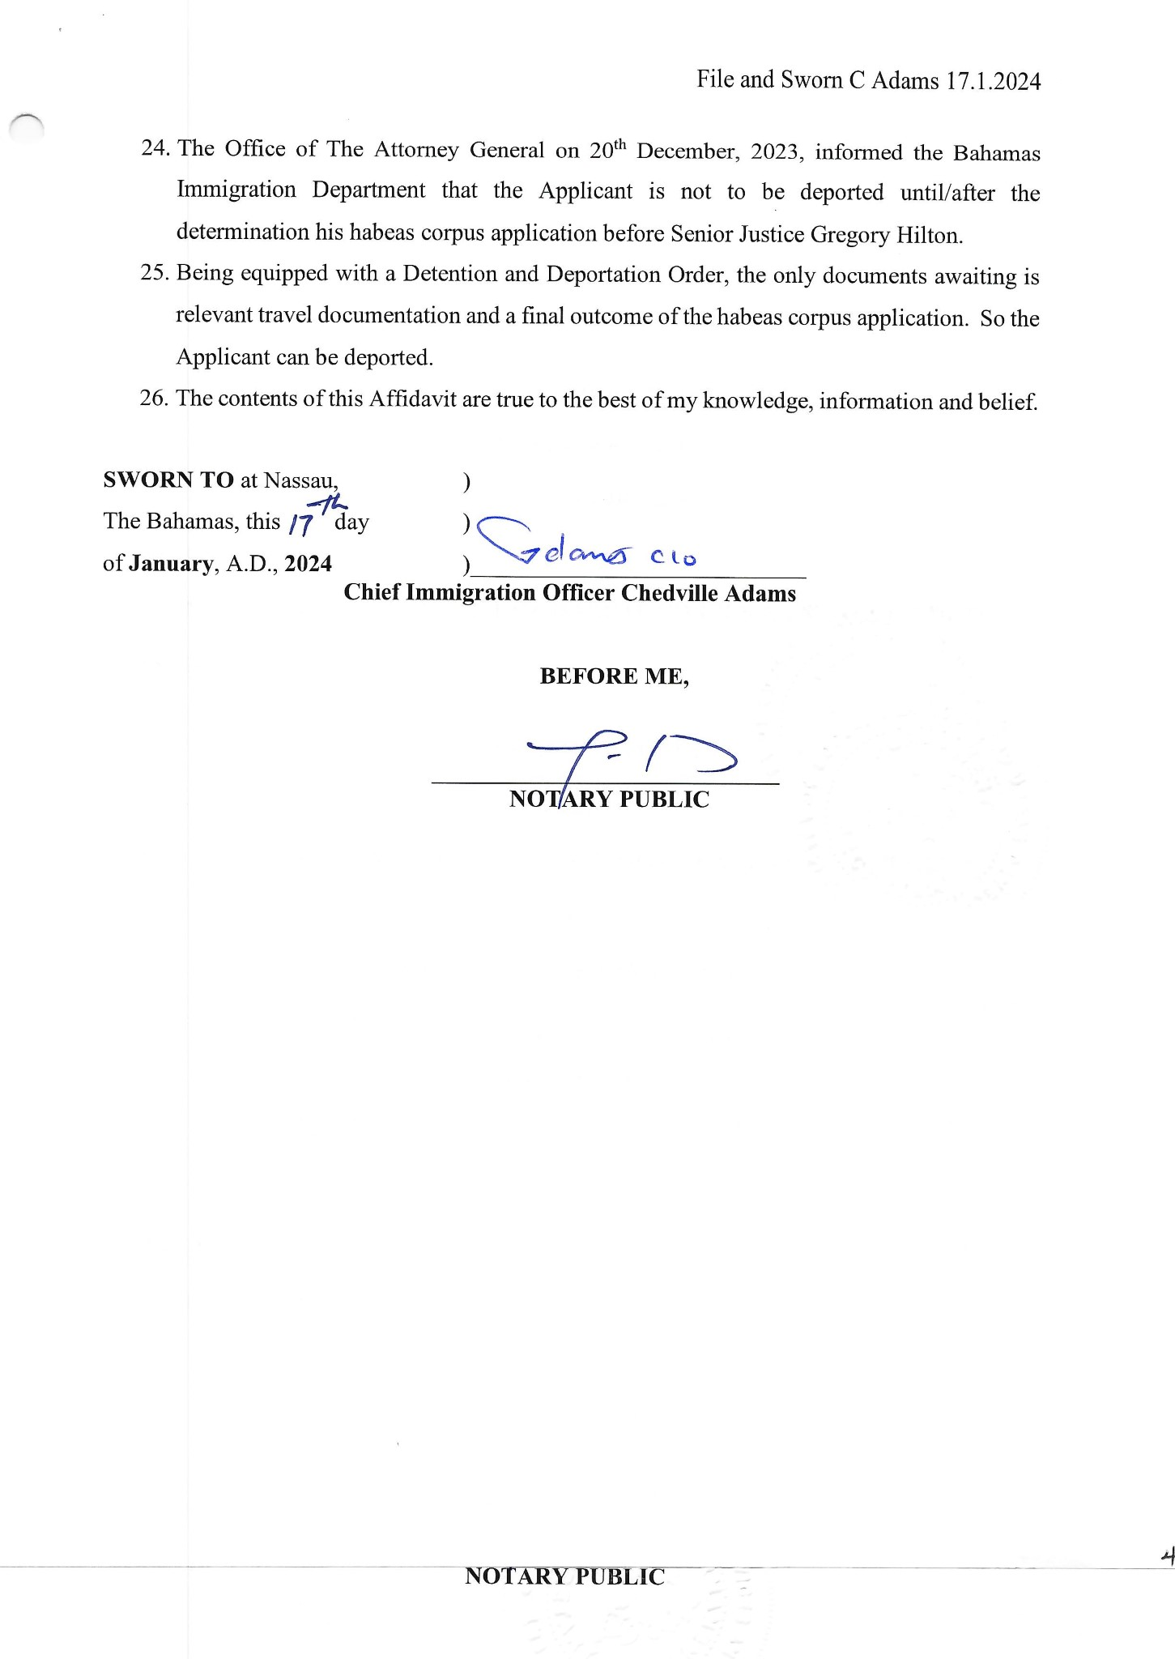
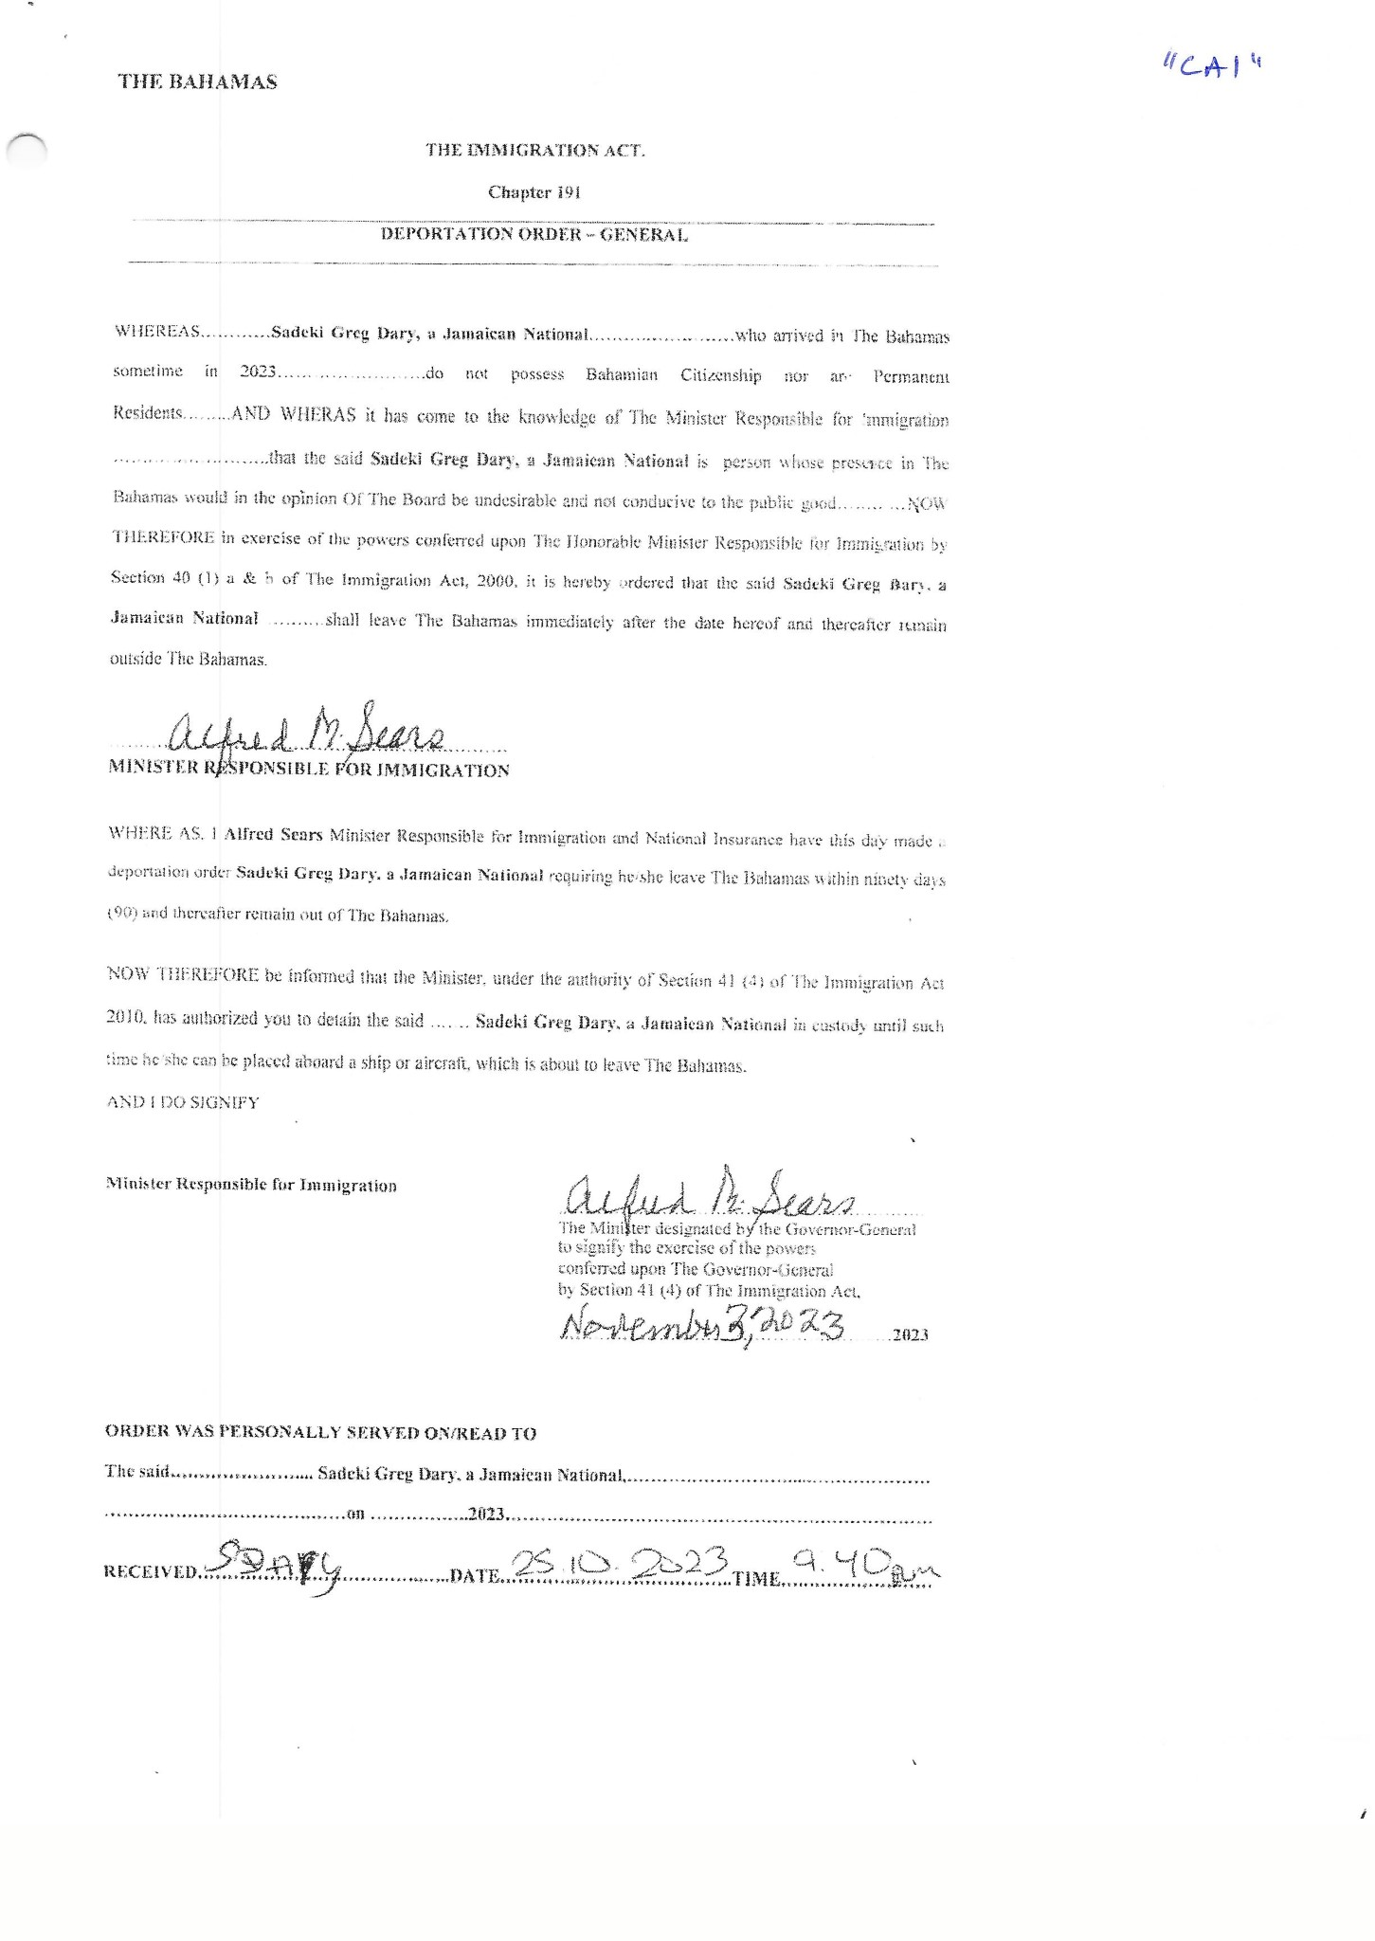
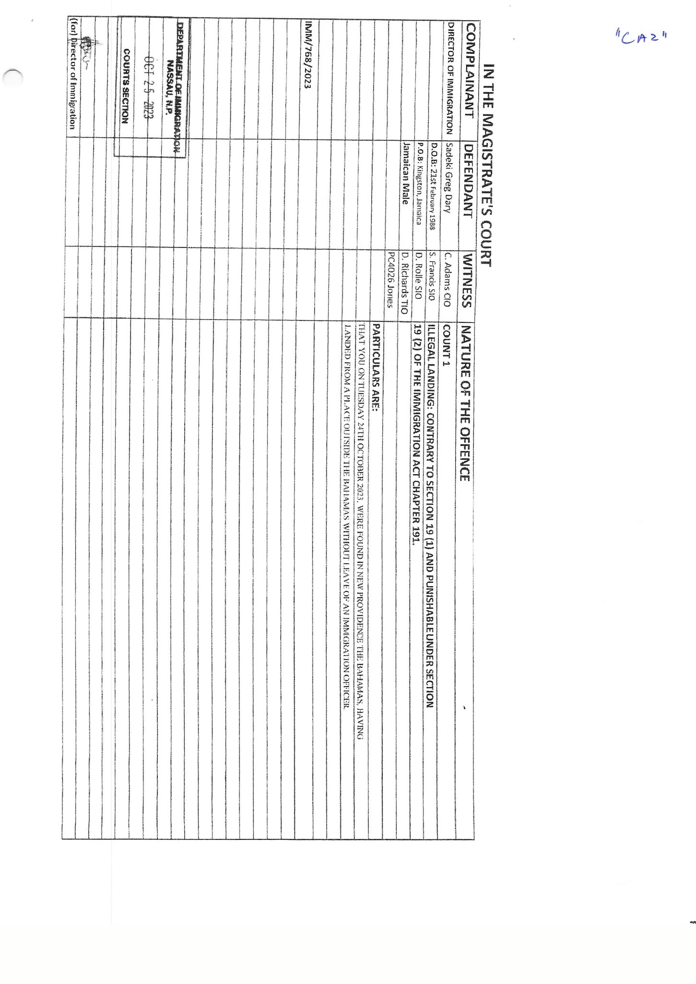
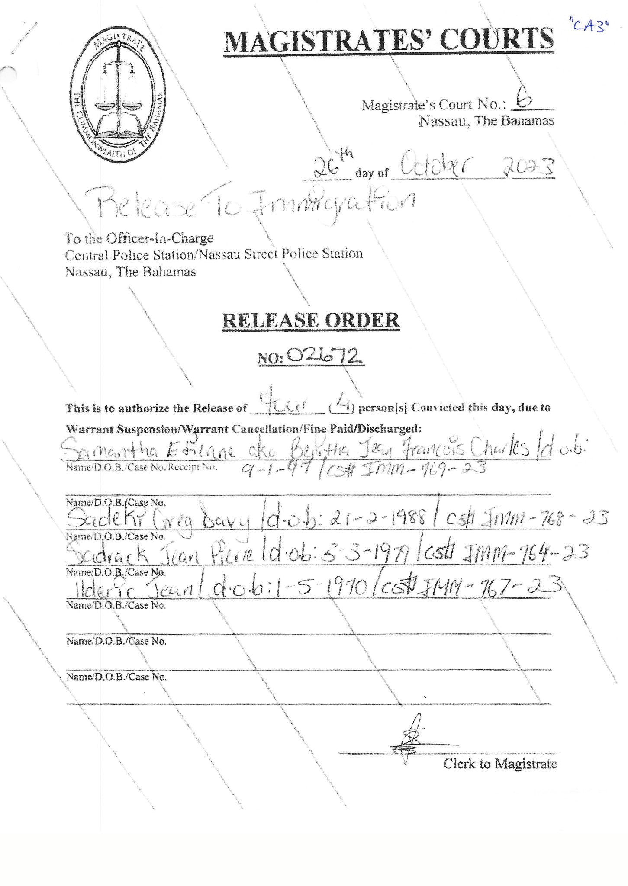
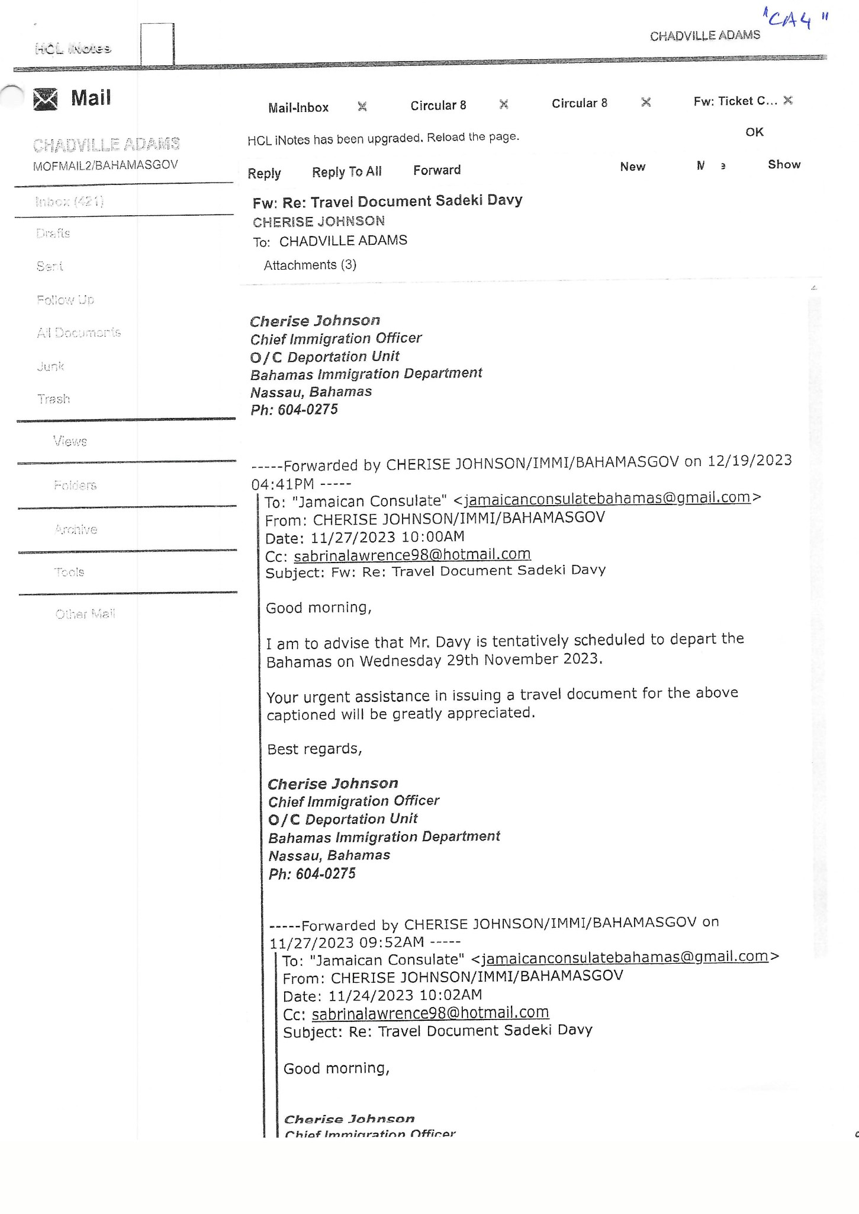
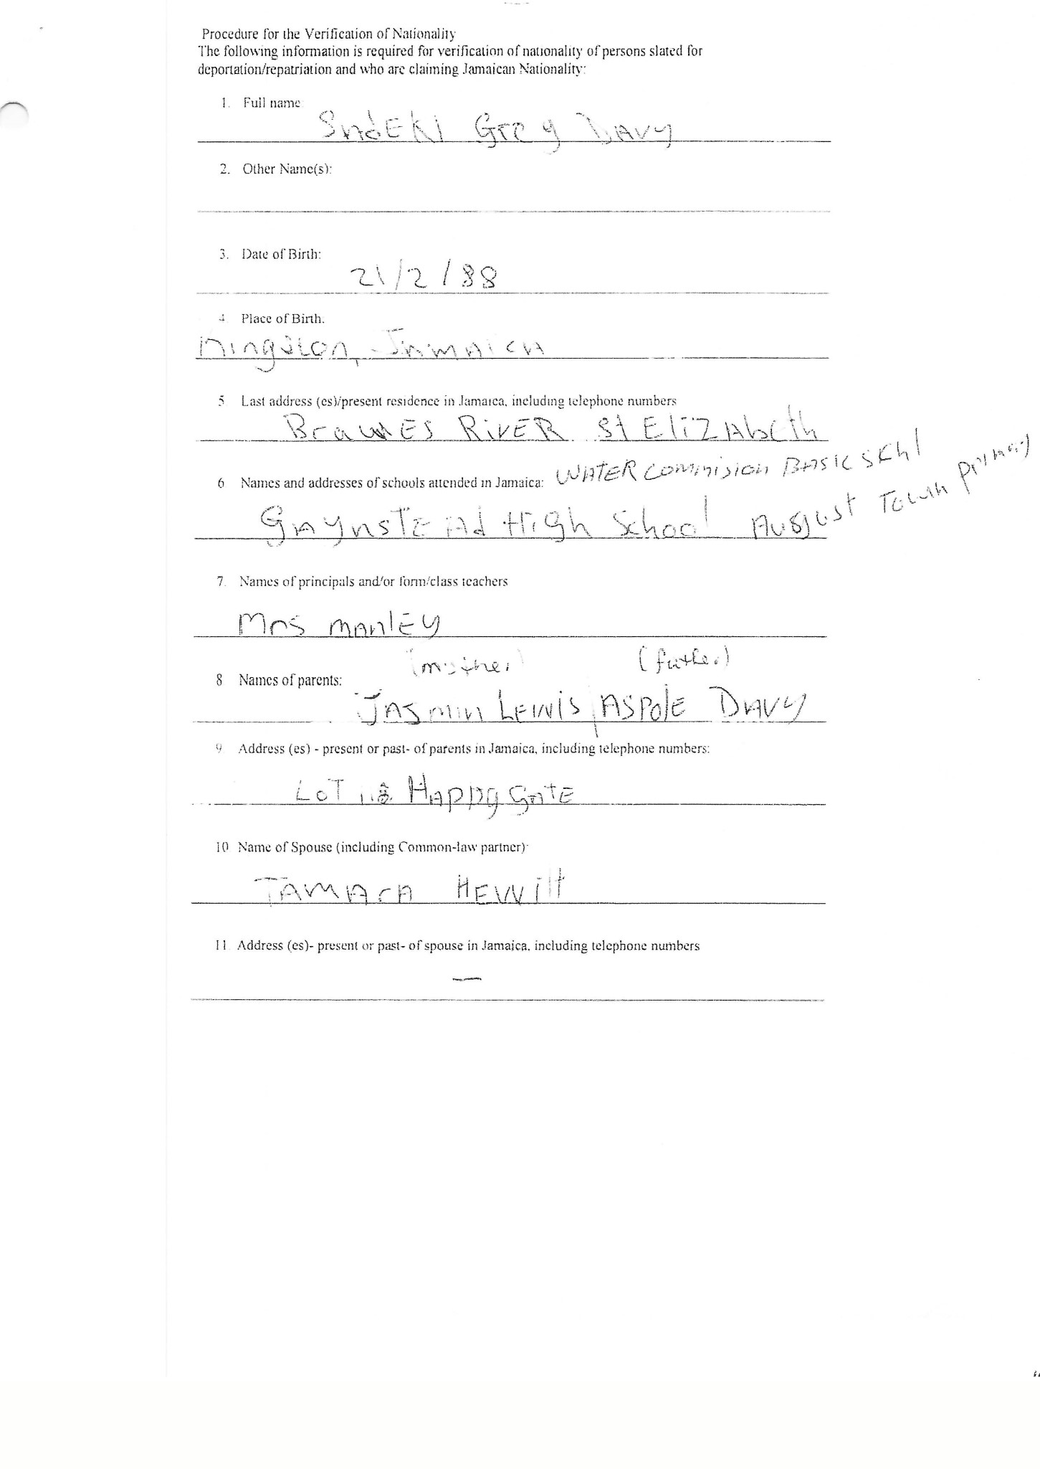
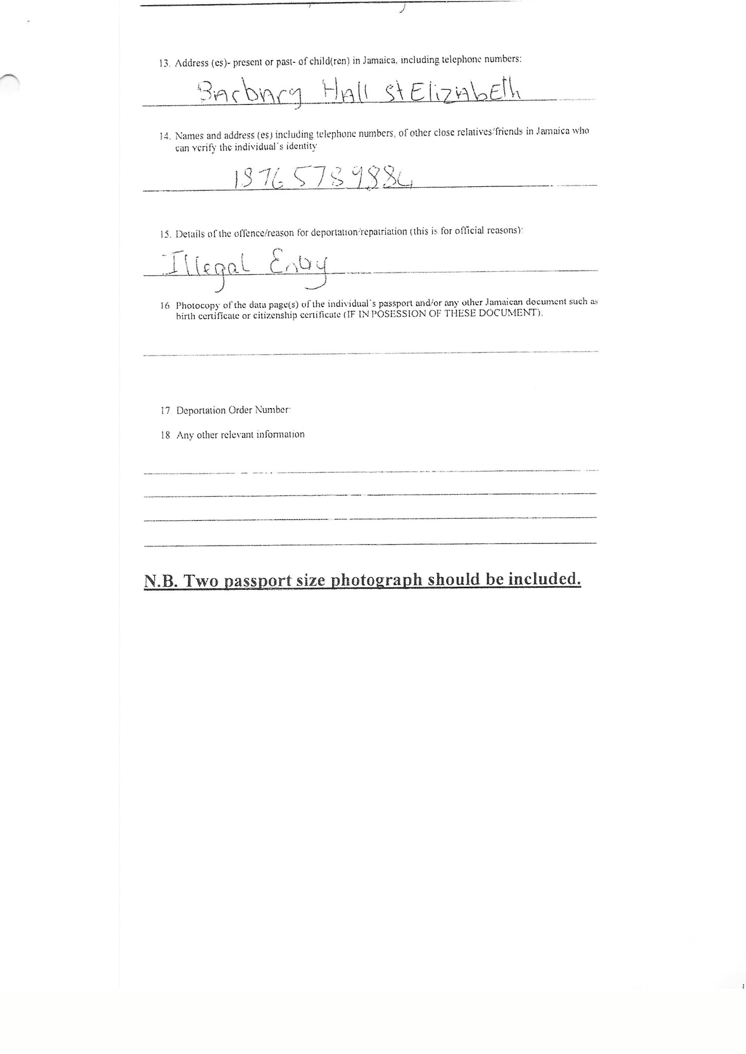
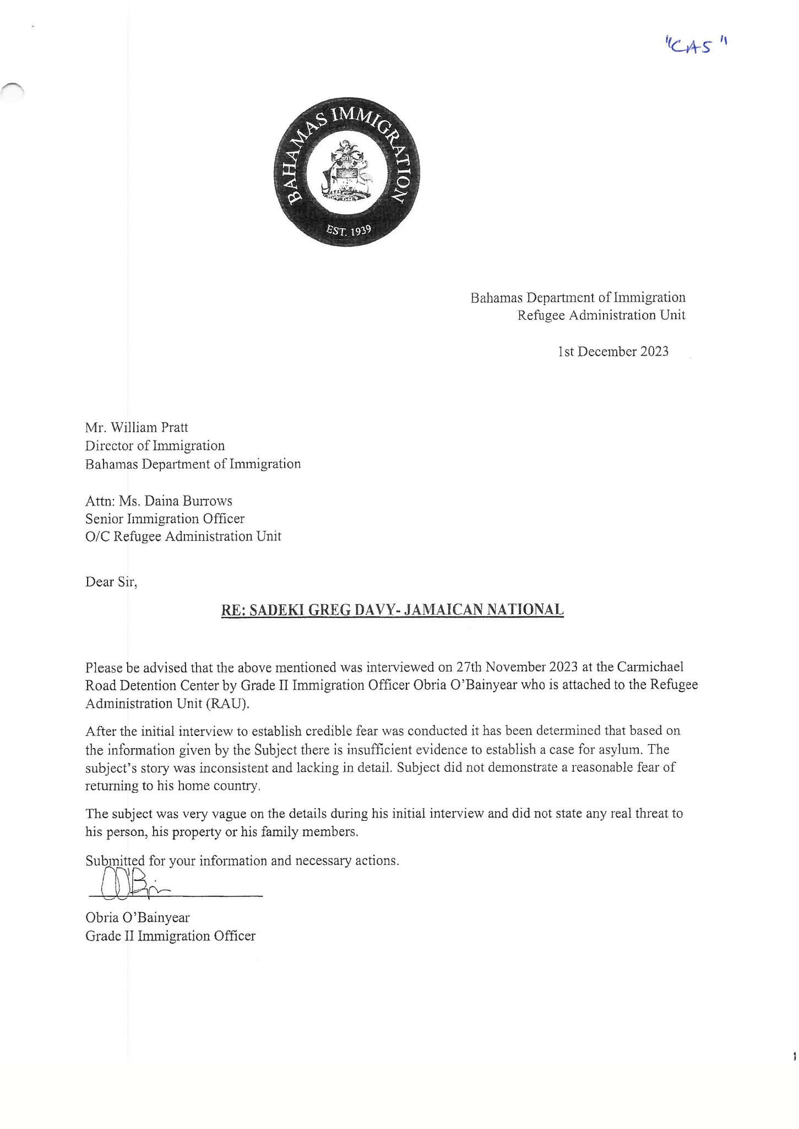

6. On the hearing on 19th January, 2024 the matter was further adjourned to 23rd January, 2024.

7. On the hearing of 23rd January, 2024 the Court on an application of the 1st Respondent and conceded to by the Applicant ordered that the 1st Respondent was not a proper party to the action and should be removed.

8. The Court heard submission from the Applicant and the Respondent on 23rd January, 2024.

9. On review of the facts outlined in the Return the Court is of the view that the application by the Applicant should be dismissed.

10. In the Court’s view the Return sufficiently and succinctly outlines the lawfulness of the detention of the Applicant pending his deportation.

11. There is no dispute that the Applicant (a Jamaican national) illegally entered the Bahamas in October 2023 and was apprehended and charged for breach of the Immigration Act. There is no dispute that the Applicant was taken to the Magistrate Court and pleaded guilty to the offence and sentenced and ordered to pay a fine and the Magistrate ordered him to be released into the custody of the Immigration Department (to await deportation).

12. The Return states that a Detention Order and a Deportation Order was presented to the Applicant and signed by the Applicant on 25th October, 2023 and the Minister responsible for Immigration signed the Deportation Order on 3rd November, 2023 and the Detention Order was also signed on 3rd November 2023.

13. The claim by the Applicant for Asylum (which he made after he pleaded guilty to illegal landing) was refused and rejected by the authorities as being without merit on 1st December, 2023.

14. The Applicant is in lawful custody awaiting deportation. The Return specifies that the only document necessary to be obtained before the deportation can occur is the necessary travel document for the Applicant that they have requested from the Jamaican Consulate.

15. In the circumstance I find that the detention of the Applicant on the face of the Return is justified.
The authorities have a reasonable period of time to remove the Applicant from The Bahamas.

Dated this 2nd day of February A. D. 2024

Gregory Hilton
Justice of Supreme Court

