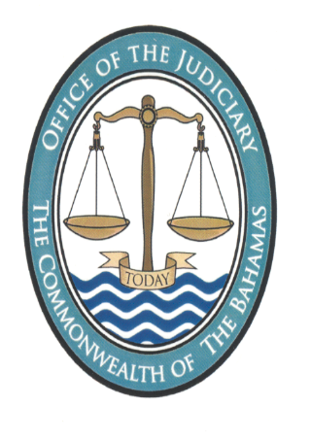
NOTICE

Pursuant to section 2 of the Juries (Amendment) Act, 2022, the 2023 Approved Jury List has been prepared by the Revising Panel. A hard copy of the Approved 2023 Jury List together with the accompanying Notice is available for inspection by any member of the public during weekdays between the hours of 9:30 am to 4:30 pm at the Chambers of The Hon. Mr. Senior Justice Bernard S.A. Turner located on the ground floor of Supreme Court Annex 1 (formerly the Ansbacher House) situate in Bank Lane, Nassau. Persons wishing to inspect the Approved 2023 Jury List may do so by attending at the Chambers of Senior Justice Turner.
The Approved 2023 Jury List shall be published on the Judiciary’s Official Website at www.bahamasjudiciary.com and in the Official Gazette. The Notice of the same will be broadcast via radio, television, and published in at least two (2) newspapers.

Registrar
4th November 2022

