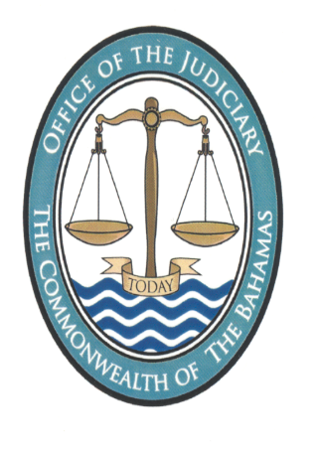

NOTICE

Pursuant to section 2 of the Juries (Amendment) Act, 2022, the 2023 Approved Jury List has been prepared by the Revising Panel. A hard copy of the Approved 2023 Jury List together with the accompanying Notice is available for inspection by any member of the public during weekdays between the hours of 9:30 am to 4:30 pm at the Supreme Court Garnet Levarity Justice Centre, Freeport Grand Bahama. .
The Approved 2023 Jury List shall be published on the Judiciary’s Official Website at www.bahamasjudiciary.com and in the Official Gazette. The Notice of the same will be broadcast via radio, television, and published in at least two (2) newspapers.

Registrar
4th November 2022

